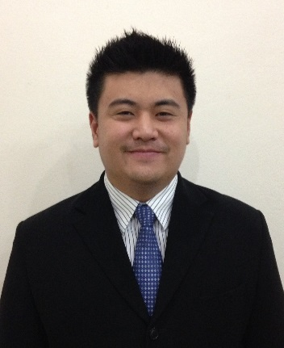**Curriculum Vitae**

**Mr. WEERAWAT BURAPAPATTANAPONG**

**Personal Data**

**Date of birth :** April 11, 1983

**Age :** 31

**Marital Status :** Single

**Nationality :** Thai

**Religion :** Buddhism

**Address :** 88/268 Moo 4, Saimai Road, Saimai, Bangkok 10220

**Contact Number :** 081-988-0933

**E-Mail :** [weerawat@veerayaoil.com](mailto:weerawat@veerayaoil.com)

**Education**

**Year 2006 - 2008 :** Master of Public Administration (Credits Transfer

From Command and General Staff College Program)

Kasem Bundit University, Bangkok, Thailand

**Year 2001 - 2005 :** Bachelor of Business Administration

Major: International Business Management (IBM)

Assumption University, Bangkok, Thailand

**Experience**

**2006 to Present :** Managing Director

Veeraya Oil Transport Co., Ltd.

223 Nikomlumtakong Road, Nongsarai,

Pakchong, Nakhonratchasima 30130

Business Detail:Land Transportation for Petroleum

Products and Relative Products

**2007 to Present :** Managing Director

Moo Thong Oil Group of Companies

138/2 Mittaphap Road, Pakchong,

Nakhonratchasima 30130

Business Detail: Petro Stations under PTT Brand in

Several Strategic Locations of Thailand

**2009 to Present :** Director

V2 Logistics Co., Ltd.

88/9 M.5 Kingkaew Road, Rachathewa, Bangphli,

Samutprakan 10540

Business Detail: Land Transportation for

Compressed Natural Gas (CNG) and Liquefied

Natural Gas (LNG)

**2010 to Present :** Director

168 Logistics Co., Ltd.

634/4 Soi Ramkhamhaeng 39 (Theplila 1)

Pracha Uthit Road, Wangthonglang, Bangkok 10310

Business Detail: Land Transportation for

Compressed Natural Gas (CNG)

**2012 to Present :** Director

V2 Transport Co., Ltd.

88/169 M.5 Kingkaew Road, Rachathewa, Bangphli,

Samutprakan 10540

Business Detail: Land Transportation for

Compressed Natural Gas (CNG)

**2013 to Present :** Managing Director

Premier Tank Corporation Co., Ltd.

111 Moo 10, Kutnamsai, Namphong, Khonkaen

40310

Business Detail:Oil Terminal for Storage Petroleum

Products and Supply to all Petro Stations under PTT

Brand in Northeastern Region of Thailand

**Reference**

Mr. Nanthiya Darakananda

Tel. 081-888-8898

President

Venus Technology Co., Ltd.

634/4 Soi Ramkhamhaeng 39 (Theplila 1) Pracha Uthit Road, Wangthonglang, Bangkok 10310